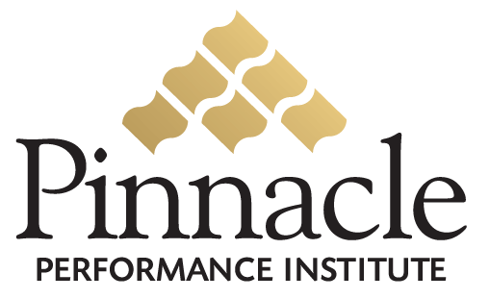

Compliance Certification System
Lexxus International, 12901 Hutton Drive, Dallas, Texas 75234

Executive Summary

Lexxus International (Lexxus), a direct sales company since 2001, markets unique consumer products internationally in over 30 countries. Lexxus has more than 300,000 independent distributors throughout the world, spanning all ages and all skill levels. Distributors represent a diversified group of men and women who are working together to exchange ideas, advance their skills, increase their knowledge, and realize their dreams.
Lexxus recognizes the significant need to train and certify their independent distributors on regulatory requirements to protect the company from legal liabilities due to unauthorized product claims, earning statements and business practices. Lexxus also recognize the need to insure that their distributors are qualified to represent the company and that they are equipped with the leadership skills to excel.
Pinnacle will develop a custom online Lexxus Performance Enhancement Solution to enable Lexxus to train and certify their distributors on regulatory requirements, qualified distributor compliance, and the necessary business and leadership skills for success.
Lexxus distributors will have access to the Lexxus Performance Enhancement Solution with unlimited access to all certifications and assessments, leadership and business development training courses, communication programs and goal management.
The Lexxus Performance Enhancement Solution has no setup or maintenance fees and will be developed at no cost to Lexxus. The Lexxus solution will be provided as a service to its distributors for compliance certification on regulatory requirements to eliminate Lexxus’ legal liabilities due to unauthorized product claims, earning statements and business practices.
In 3-4 weeks the Lexxus Performance Enhancement Solution will be implemented and ready for use by the distributors. An Account Executive assigned by Pinnacle will partner with the Lexxus Program Manager with custom solution implementation and ongoing solution support. The Pinnacle customer support department will also provide additional assistance for the program manager, trainers and members.

